**IBM CLOUD REGISTRATION**

**Team Lead: Pratheeba R**

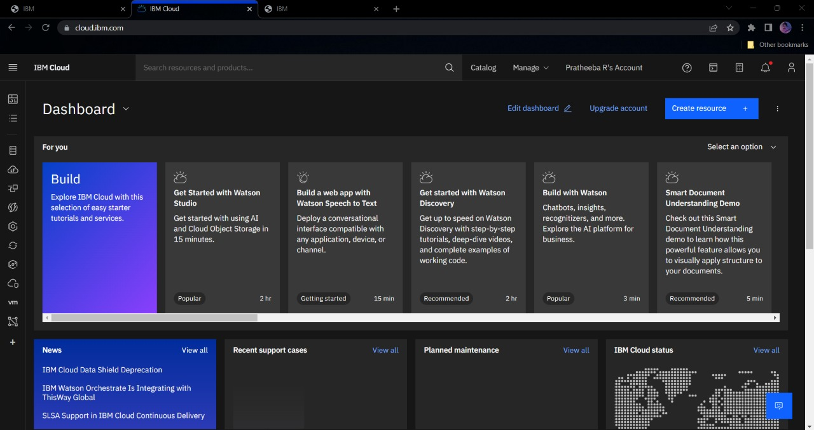

**Team Member 1: Sai Raksha V**

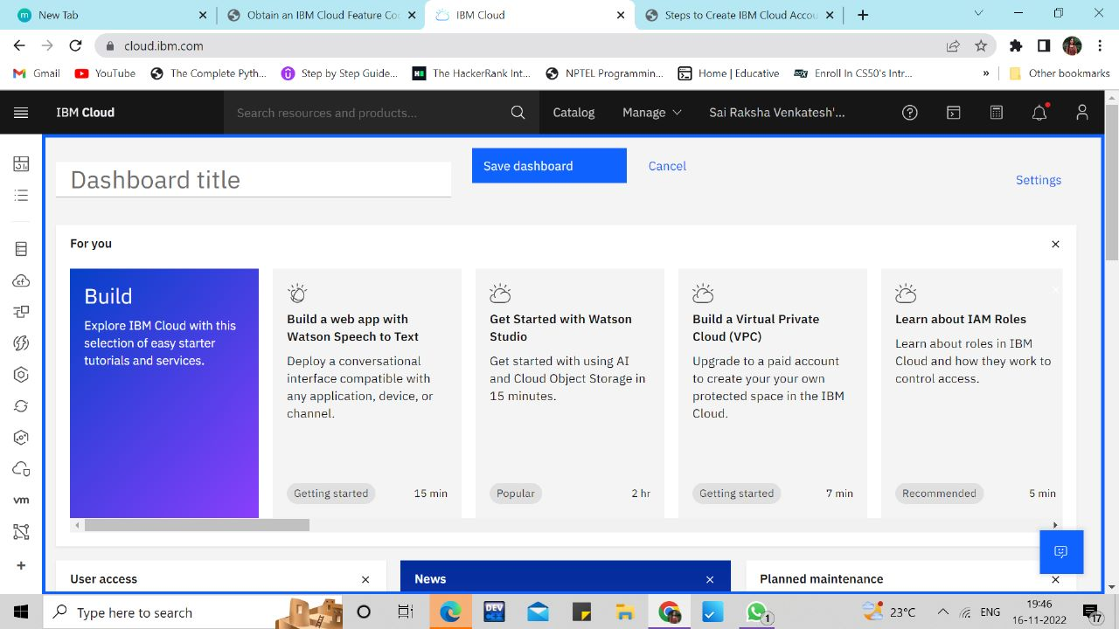

**Team Member 2: Sandhiya R**

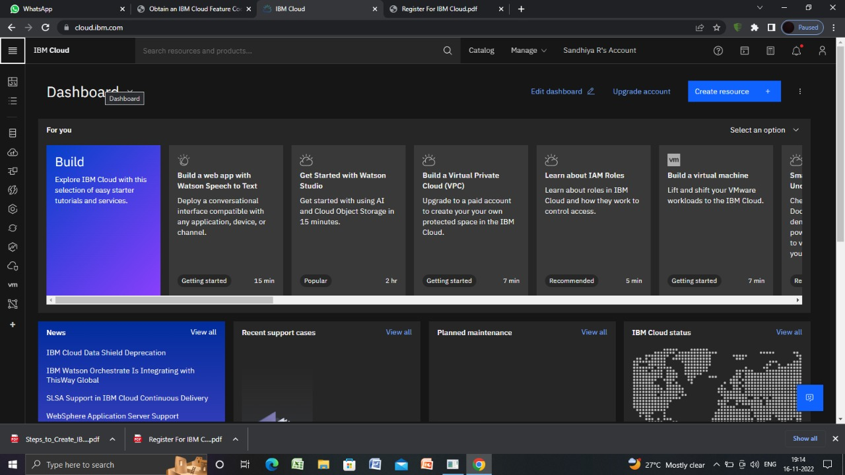

**Team Member 3: Suriya R**

